Class Diagram

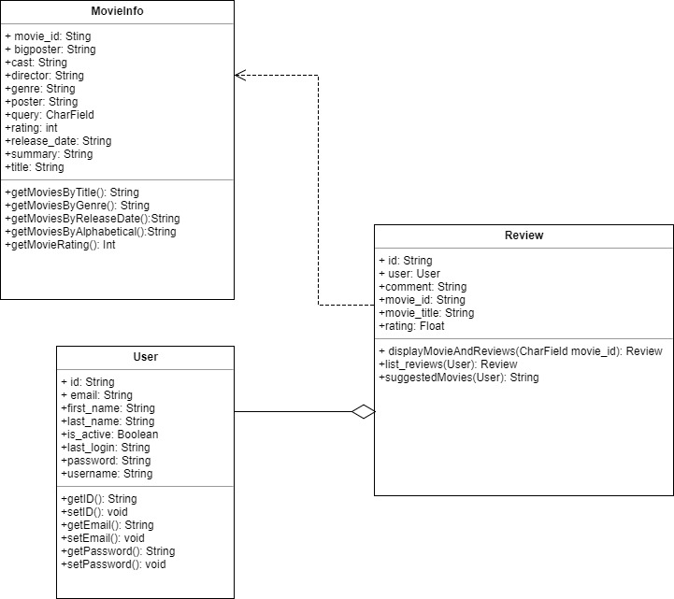

Relational Diagram

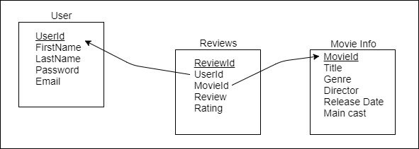

ERD

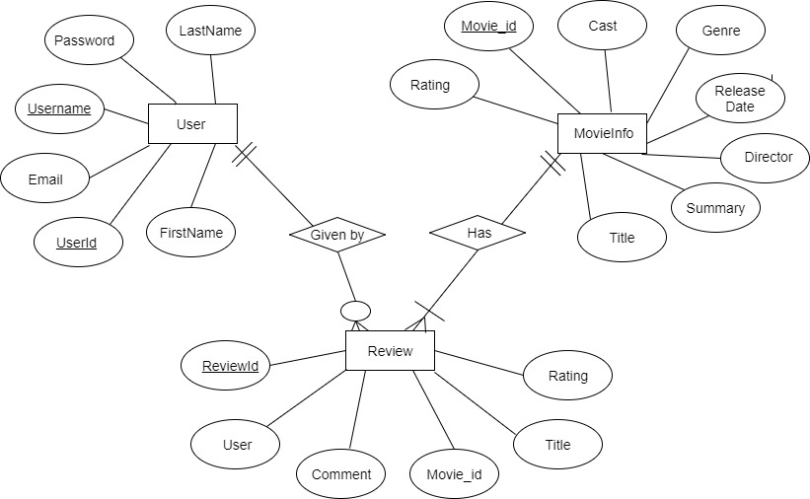

Sequence Diagrams

1. User can log in/register to make reviews with ratings.

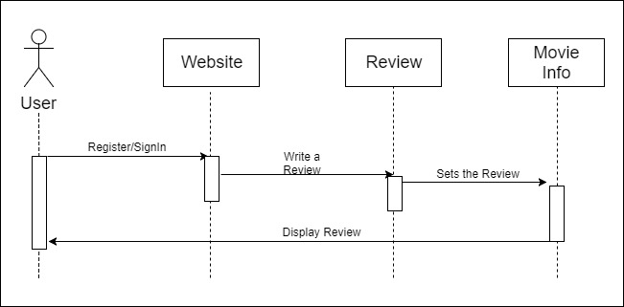

1. User can search a movie by title, alphabetical, release year, or genre

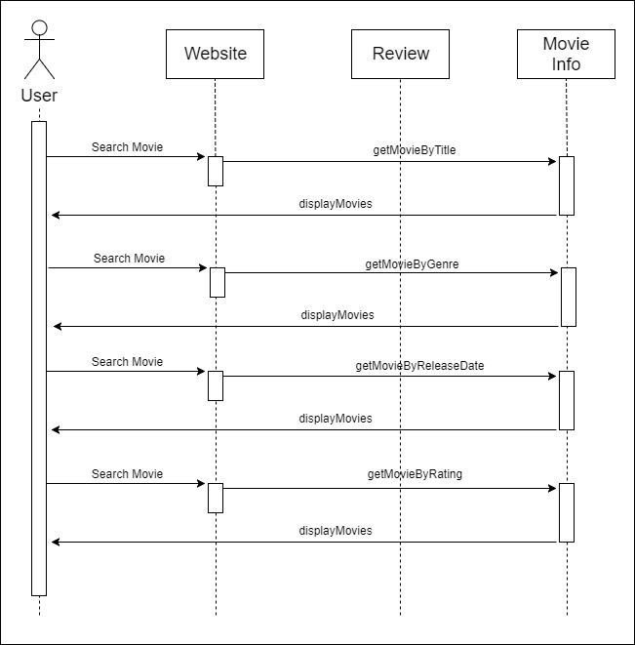

1. User can select a movie and view its information based on main cast, director, genres, and release year.

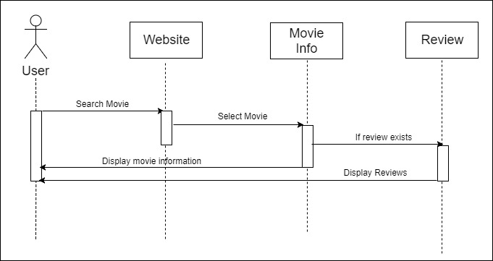

1. User can access suggested searches for movies based on movies they review. 